**Properties:**

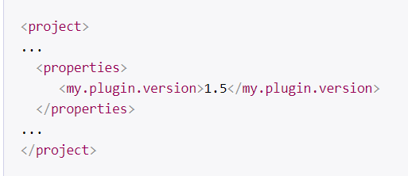

We can create properties in pom.xml and use them as below

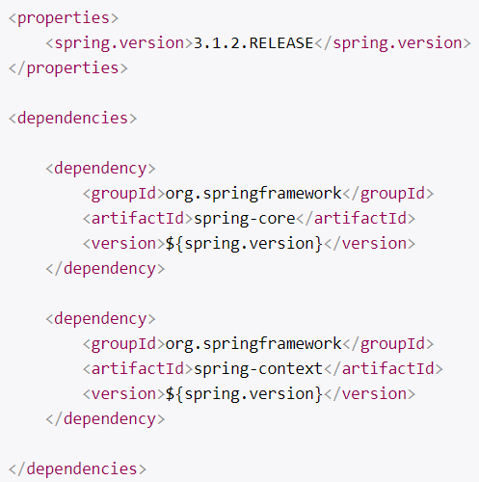

**Profiles:**

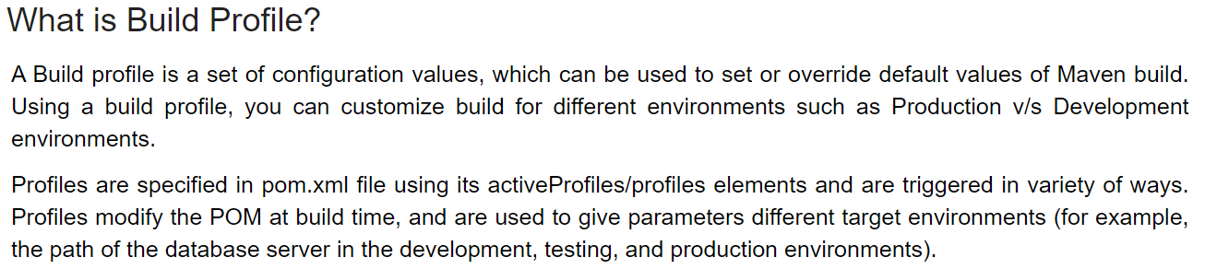

**Types of profiles:**

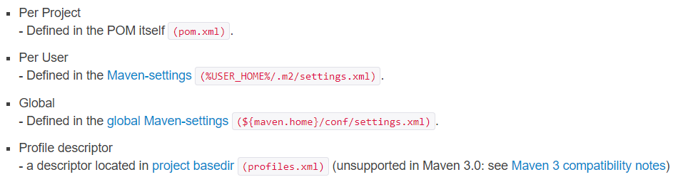

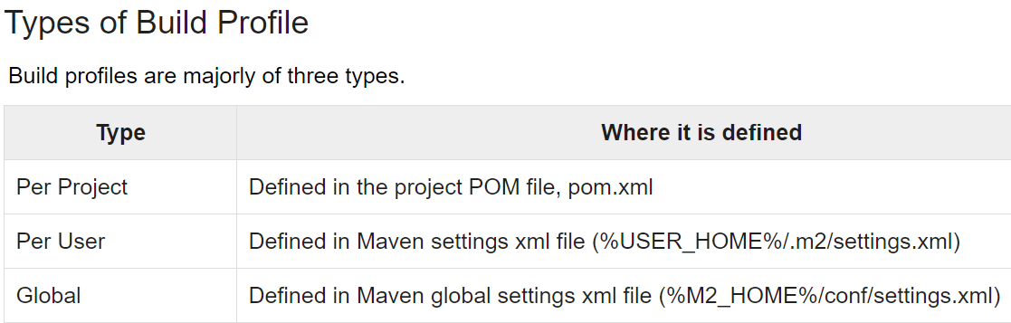

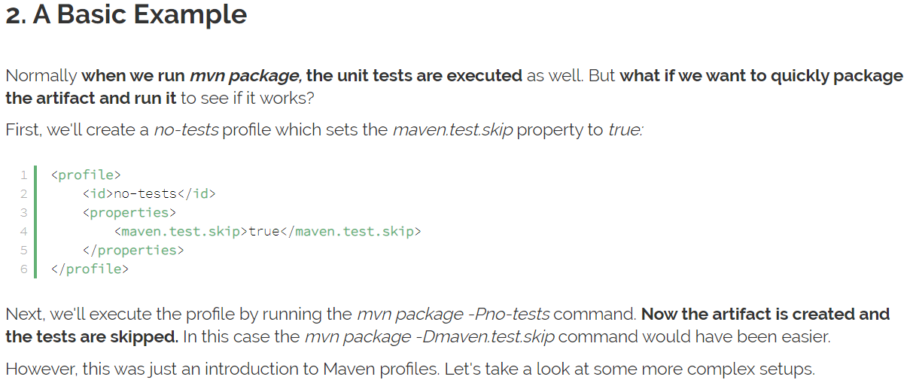

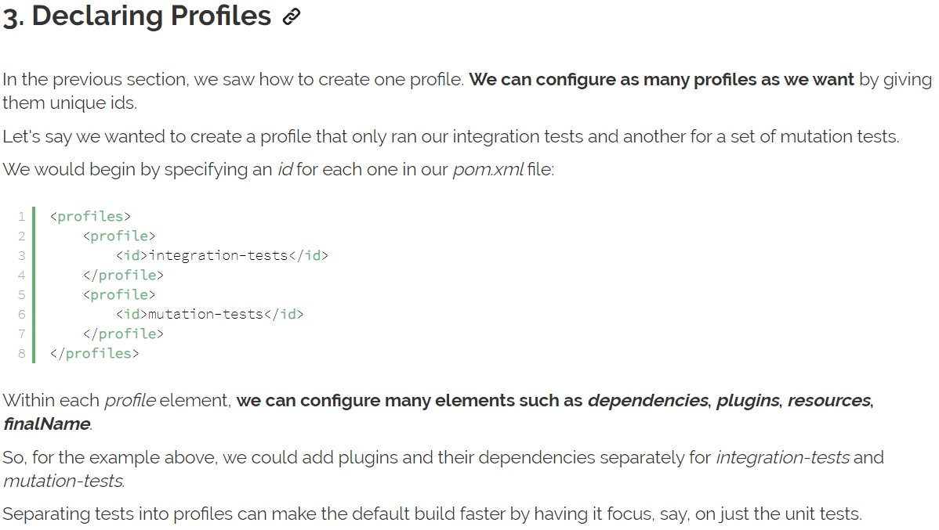



**Activate profile:**

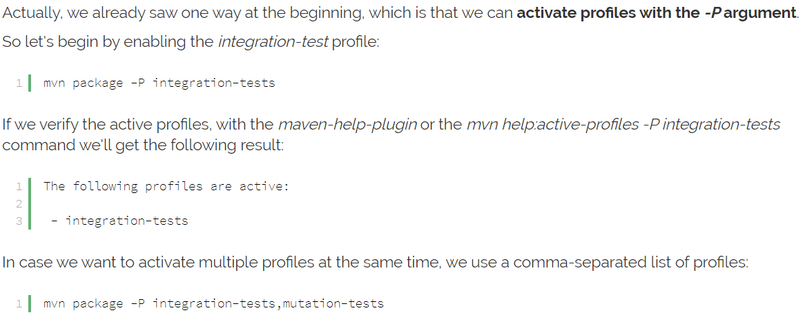

**Activate profile by default:**

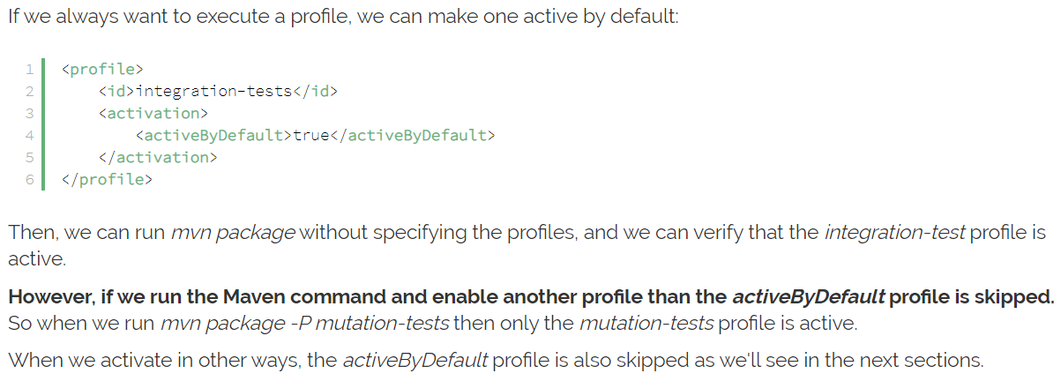

We can also set the value to false

**Activate with property:**

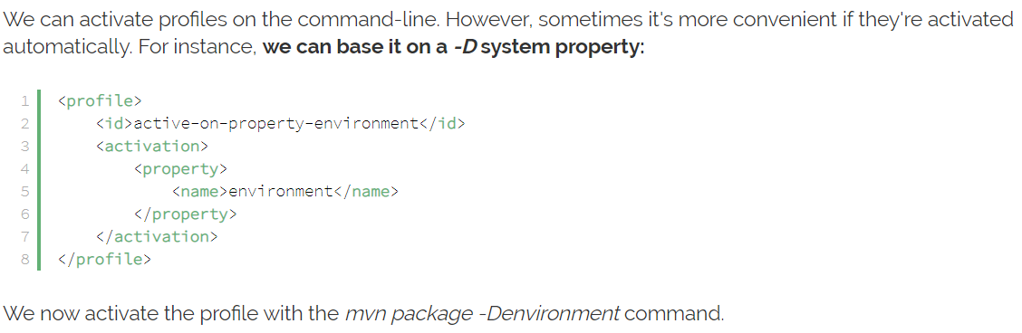

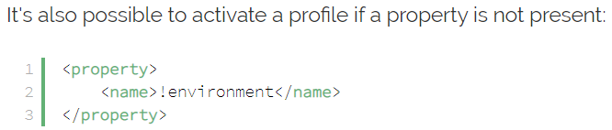

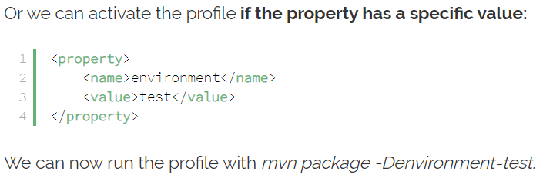

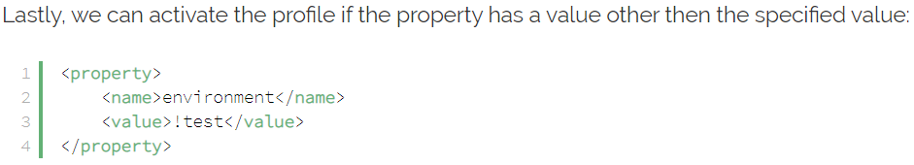

**Activate based on a file:**

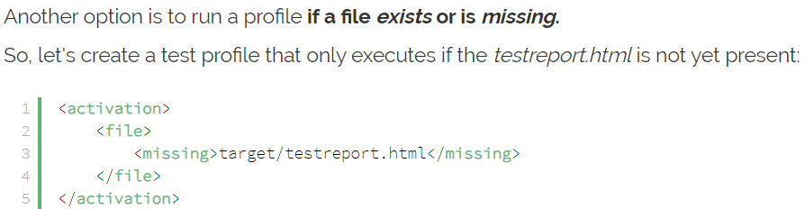

We can also activate the profile based on operating system and jdk version

**Deactivating a profile:**

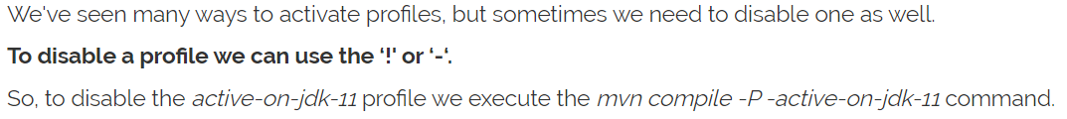

**Examples:**

